[Backlog SOW Title]
Business User Story ID: | [BUS-yymmdd-xx] | Feature Story ID: | [FUS-yymmdd-xx]
Product Backlog ID: | [SBL-yymmdd-xx] | Sprint Iteration: | [SBL-yymmdd-xx]
SOW Designer: | [FullName] | Design Date: | [January 2, 2014]
Designer Email: | [DesignerEmailAddress] | Designer Phone: | [Primary Phone Number]

Business User Story Backlog Item Mapping to Development Acceptance Criteria:
Feature Story: | In order to | What you want to do?
 | As a | Who wants to do it?
 | I want to | How do you want it done?

Acceptance Scenario: | Given | What are your dependencies?
 | When | Should this scenario be in play?
 | Then | What are the QA Objectives criteria?

Design Details Overview:
Lorem ipsum dolor sit amet, consectetur adipiscing elit. Cras cursus ipsum eget adipiscing sagittis. Maecenas pretium nec nibh in dapibus. Nam magna arcu, molestie ac nunc eu, cursus faucibus dolor.
Vivamus sagittis iaculis laoreet. Nulla sollicitudin quam a diam laoreet convallis. Quisque urna nibh, bibendum a vestibulum ut, tempus ac enim. Integer facilisis justo ut urna pulvinar, vitae euismod tortor elementum. Nullam interdum varius leo in commodo. Cum sociis natoque penatibus et magnis dis parturient montes, nascetur ridiculus mus. Suspendisse suscipit at tellus pharetra laoreet. Suspendisse iaculis semper nunc, id iaculis massa.
Praesent dignissim mollis ante, vel pulvinar massa interdum a. Nunc vitae vestibulum ligula. Vivamus in lacinia magna, et facilisis ligula. Phasellus hendrerit volutpat tortor. Cras porta ultricies mauris adipiscing vestibulum. Nam consectetur lacinia lectus, at gravida diam faucibus quis.
Fusce non leo et lectus rutrum placerat. Nullam vitae augue sit amet erat feugiat bibendum. Curabitur at nisi magna. In feugiat quis metus quis luctus. Donec ut turpis quis est scelerisque aliquam. Aenean tincidunt sit amet massa eget viverra. Vestibulum elit purus, cursus tempus sapien eget, blandit lobortis erat. Integer eget ipsum egestas, tempor leo ultricies
List of Possible Dependency Requirements for the Scenario:
Dependency | Type | Description | Details

List of Currently Available Service Requirements for the Scenario:
Service | Type | Description | URI

User Interface Wireframes (Screenshots):
Description | Image
Praesent dignissim mollis ante, vel pulvinar massa interdum a. Nunc vitae vestibulum ligula. Vivamus in lacinia magna, et facilisis ligula. Phasellus hendrerit volutpat tortor. Cras porta ultricies mauris adipiscing vestibulum. Nam consectetur lacinia lectus, at gravida diam faucibus quis. | 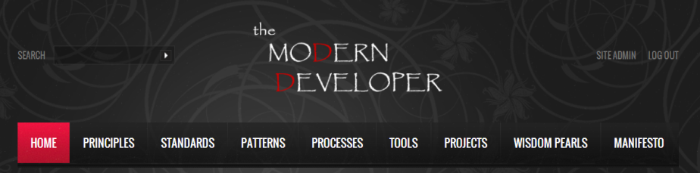
Praesent dignissim mollis ante, vel pulvinar massa interdum a. Nunc vitae vestibulum ligula. Vivamus in lacinia magna, et facilisis ligula. Phasellus hendrerit volutpat tortor. Cras porta ultricies mauris adipiscing vestibulum. Nam consectetur lacinia lectus, at gravida diam faucibus quis.  a vestibulum ut, tempus ac enim. Integer facilisis justo ut urna pulvinar, vitae euismod tortor elementum. Nullam interdum varius leo in commodo. Cum sociis natoque penatibus et magnis dis parturient montes, nascetur ridiculus mus. Suspendisse suscipit at tellus pharetra laoreet. Suspendisse iaculis semper nunc, id iaculis massa. | 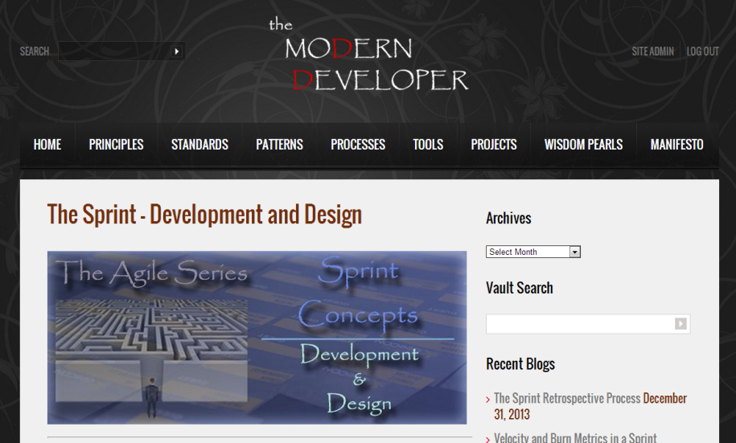

Sequence Diagram:
Below sequence diagram provides sequence of operations and its break up of logic across tiers.
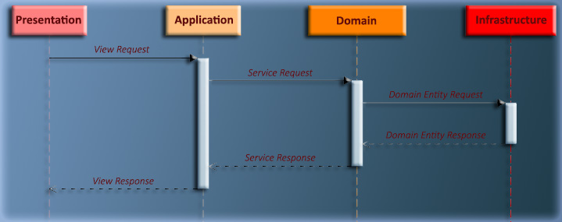

Use Case Example:
Use Case | SOW Use Case Details
Description: | Praesent dignissim mollis ante, vel pulvinar massa interdum a. Nunc vitae vestibulum ligula. Vivamus in lacinia magna, et facilisis ligula. Phasellus hendrerit volutpat tortor. Cras porta ultricies mauris adipiscing vestibulum. Nam consectetur lacinia lectus, at gravida diam faucibus quis.
Actors: | Praesent dignissim mollis ante, vel pulvinar massa interdum.
Assumptions: | Praesent dignissim mollis ante, vel pulvinar massa interdum a. Nunc vitae vestibulum ligula. Vivamus in lacinia magna, et facilisis ligula. Phasellus hendrerit volutpat tortor. Cras porta ultricies mauris adipiscing vestibulum. Nam consectetur lacinia lectus, at gravida diam faucibus quis.
Prerequisites: | Praesent dignissim mollis ante, vel pulvinar massa interdum a. Nunc vitae vestibulum ligula. Vivamus in lacinia magna, et facilisis ligula
Primary Steps: | Praesent dignissim mollis ante, vel pulvinar massa interdum a. Nunc vitae vestibulum ligula. Vivamus in lacinia magna, et facilisis ligula. Phasellus hendrerit volutpat tortor. Cras porta ultricies mauris adipiscing vestibulum.
Alternate Steps: | Praesent dignissim mollis ante, vel pulvinar massa interdum a. Nunc vitae vestibulum ligula. Vivamus in lacinia magna, et facilisis ligula.

Designer Notes:
Lorem ipsum dolor sit amet, consectetur adipiscing elit. Cras cursus ipsum eget adipiscing sagittis. Maecenas pretium nec nibh in dapibus. Nam magna arcu, molestie ac nunc eu, cursus faucibus dolor.
Praesent dignissim mollis ante, vel pulvinar massa interdum a. Nunc vitae vestibulum ligula. Vivamus in lacinia magna, et facilisis ligula. Phasellus hendrerit volutpat tortor. Cras porta ultricies mauris adipiscing vestibulum. Nam consectetur lacinia lectus, at gravida diam faucibus quis.

